Dancing Robot

# Introduction

This article is about an oscillator robot driver circuit. The article is most about the diode protection circuit ideas for the oscillator and power supply.

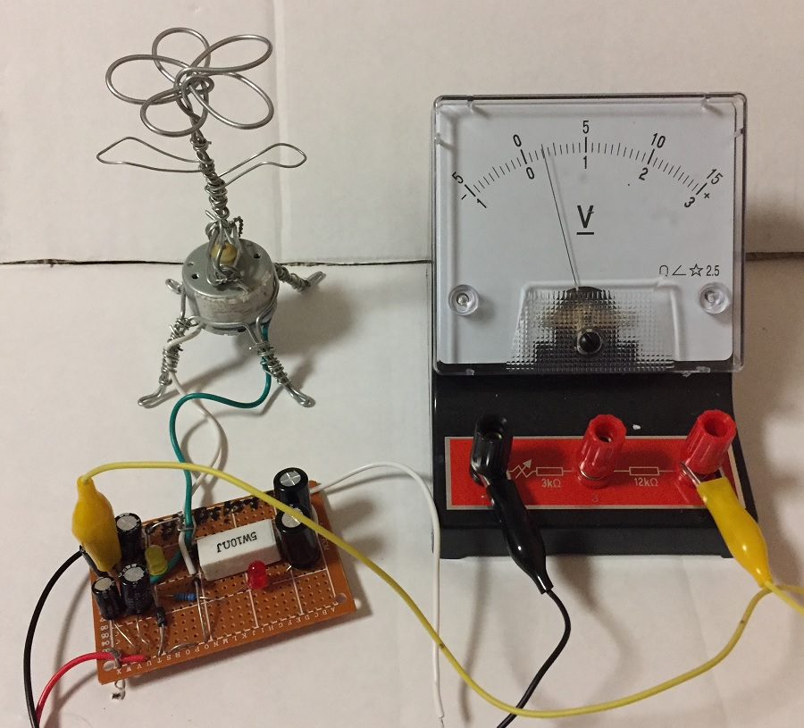

**Figure 1:** Flower Robot

You can purchase power amplifiers/motor drivers on (eBay, Aliexpress or Amazon) and connect motors to output power amplifiers. You connect the inputs of power amplifiers/motor drivers to computer sound card outputs. This output could be either speaker/earphone or line out.

You also need to consider grounding issues. It might be a good idea to use either a battery powered computer, battery powered power amplifier/motor driver or both devices powered by a battery. There could be an AC mains signal phase difference between the input/output if one of your devices in your system is not grounded.

There is another design that works for high current motors:

[https://www.instructables.com/id/Waving-Robot](https://www.instructables.com/id/Waving-Robot/)

# Tools and Supplies

**Components:** 8 pin wire wrap socket, 555 timer - 3 (you only need 1), wire wrap wire (3 colours), wire wrap tool, low current DC motor, matrix board, 1000 uF capacitor - 2, high power 10 ohm resistor - 2, general-purpose diodes - 4 (do not buy low power), 10 kohm resistor, 100-kohm resistor, 1 Megohm variable resistor, 470 nF capacitor, 10 nF capacitor, 6 V or 9 V battery with harness,

**Other items for robots:** 1 mm metal wire, or cardboard with sticky tape.

**Tools:** pliers, wire stripper.

**Optional components:** 100 uF bipolar capacitors - 2, solder, 2 mm metal wire.

**Optional tools:** soldering iron, multimeter, voltmeter, signal generator.

# 

# 3. Step 1: Design the Circuit

The circuit design includes a 555 timer that I did not use. This IC might not be able to supply enough current for your motor. Thus you need to use a low current motor.

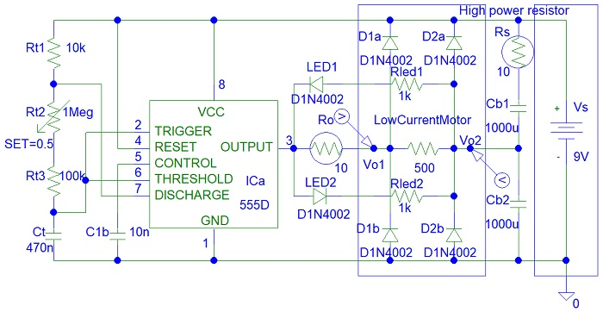

**Figure 2:** PSpice Drawing

You might need to increase Ct to 47 uF and reduce Rt resistors by 10 (Rt2 = 100 kohm and Rt3 = 10 kohm variable resistor). The best frequency for this circuit is 0.1 Hz to 10 Hz.

The four diodes are very important to protect the 555 timer and capacitors from motor discharging currents of the DC motor.

The LEDS are optional. You do not need them.

Ro is used for protecting the 555 timer when the motor movement is impeded and the motor is a short circuit.

Rt2 controls the square wave frequency.

You can click on this link to learn about 555 timer frequency calculations.

<https://www.electronics-tutorials.ws/waveforms/555_timer.html>

# 4. Step 2: Build the Circuit

I made the circuit with a matrix board:

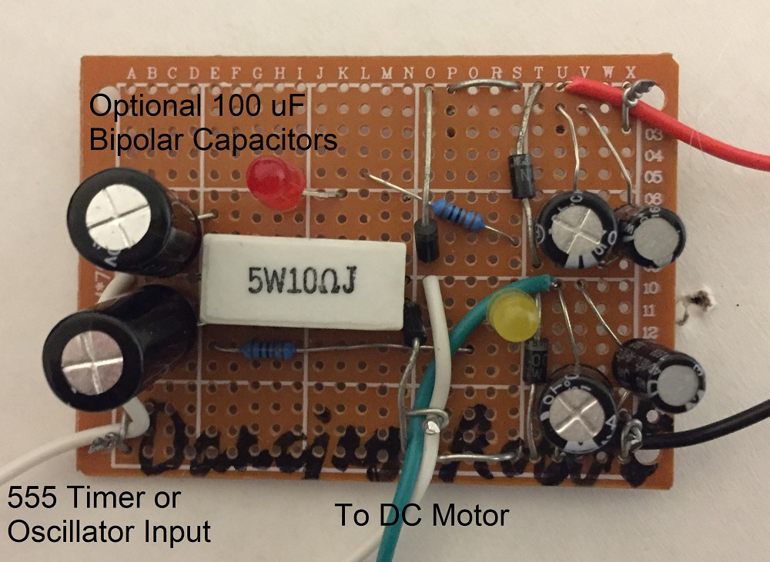

**Figure 3:** Making Circuit Photo 1

I attached two 100 uF bipolar capacitors (the biggest capacitors in the circuit that you see on the left) in series with the 10-ohm resistor. You do not need such a high power resistor that I used because 555 timers cannot supply very high currents anyway.

I did not include the 10-ohm resistor in series with the Cb1 capacitor. I thought it was not necessary because my power supply was low current. I used 330 uF (smaller one on the right) and 470 uF (bigger one on the left) electrolytic capacitors in parallel for Cb1 and the same for Cb2. This is 800 uF, not 1000 uF. I used what I had left from a mixed electrolytic capacitor pack from <https://amazon.com>

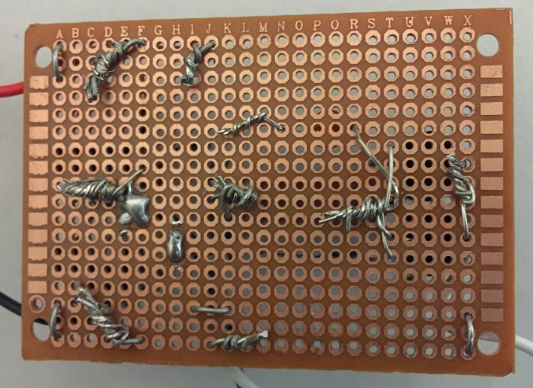

**Figure 4:** Making Circuit Photo 2

# 5. Step 3: Build the Robot

You can make any robot that you want. Keep in mind that a 555 timer might not be able to provide enough current to rotate the weight of your sculpture. Thus the moving parts must be very lightweight. The motor must be a low current motor to prevent failure of the 555 timer.

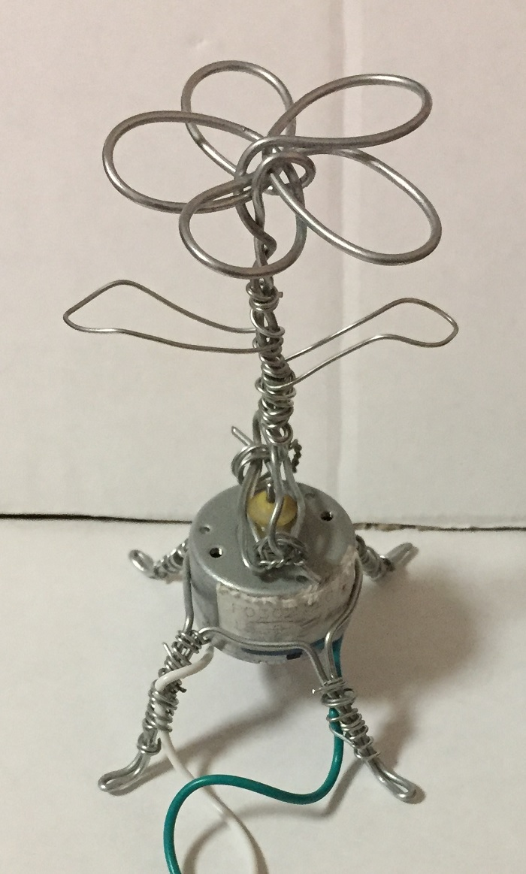

**Figure 5:** Build the robot

# 6. Step 4: Testing

I used a signal generator to test the circuit.

I applied square wave, pulse width modulation (PWM), sine wave and triangle wave. The circuit does not work well with sine or triangle waveforms. It needs a higher amplitude.

You can watch videos on YouTube of my circuit.

# 

# 7. Conclusion

The DIY Electronics project is a collaborative project between people in different countries.